Jayabalan, Ashok Kumar

Abstract

[Draw your reader in with an engaging abstract. It is typically a short summary of the document.   
When you’re ready to add your content, just click here and start typing.]

Azure vm

**Create a new Windows virtual machine**

We can create Windows VMs with the Azure portal, Azure CLI, or Azure PowerShell. The easiest approach is the portal because it walks you through the required information and provides hints and helpful messages during the creation of the VM.

1. Sign into the [Azure portal](https://portal.azure.com/learn.docs.microsoft.com) using the same account you activated the sandbox with.
2. On the Azure portal menu or from the **Home** page, select **Create a resource**.
3. In the search box, enter **Windows Server** and then click on the link with the same title in the presented list.

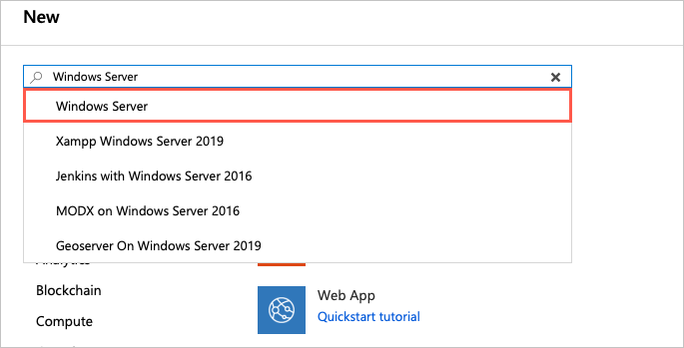

1. There are several Windows Server versions we can select from to create our VM. In the *Windows Server* image overview panel, click on the **Select a software plan** dropdown list and find the **[smalldisk] Windows Server 2019 Datacenter** option.
2. Click the **Create** button to start configuring the VM.

**Configure the VM settings**

The VM creation experience in the portal is presented in a "wizard" format to walk you through all the configuration areas for the VM. Clicking the "Next" button will take you to the next configurable section. However, you can move between the sections at will with the tabs running across the top that identify each section.

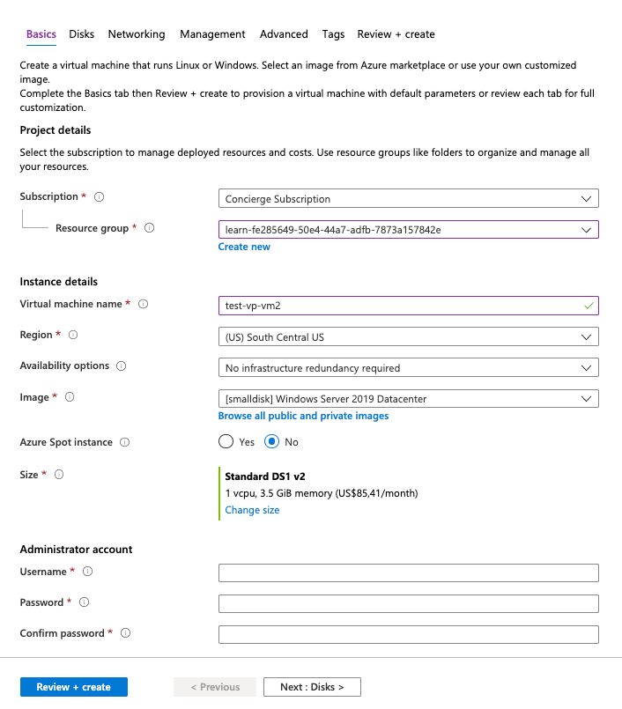

Once you fill in all the required options (identified with red stars), you can skip the remainder of the wizard experience and start creating the VM through the **Review + Create** button at the bottom.

We'll start with the **Basics** section.

**Configure basic VM settings**

**Note**

As you change settings and tab out of each free-text field, Azure will validate each value automatically and place a green check mark next to it when it's good. You can hover over error indicators to get more information on issues it discovers.

1. Select the **Subscription** that should be billed for VM hours.
2. For **Resource group**, choose "**[sandbox resource group name]**".
3. In the **Instance Details** section, enter a name for your VM, such as **test-vp-vm2** (for Test Video Processor VM #2).
   * It's best practice to standardize your resource names so you can easily identify their purpose. Windows VM names are a bit limited - they must be between 1 and 15 characters, cannot contain non-ASCII or special characters, and must be unique in the current resource group.
4. Select a region close to you from the locations below.

The free sandbox allows you to create resources in a subset of the Azure global regions. Select a region from the following list when you create resources:

* + West US 2
  + South Central US
  + Central US
  + East US
  + West Europe
  + Southeast Asia
  + Japan East
  + Brazil South
  + Australia Southeast
  + Central India

1. Leave **Availability options** as "No Infrastructure redundancy required". This option is used to ensure the VM is highly available by grouping multiple VMs together a set to deal with planned or unplanned maintenance events or outages.
2. Ensure the image is set to "[smalldisk] Windows Server 2019 Datacenter". You can open the drop-down list to see all the options available.
3. The **Size** field is not directly editable and has a DS1 default size. Click the **Change size** link to explore other VM sizes. The resulting dialog allows you to filter based on # of CPUs, Name, and Disk Type. Select "Standard DS1 v2" (normally the default) when you are done. That will give the VM 1 CPU and 3.5 GB of memory.

**Tip**

You can also just slide the view to the left to get back to the VM settings as it opened a new window off to the right and slid the window over to view it.

1. In the **Administrator Account** section, set the **Username** field to a username you will use to sign in to the VM.
2. In the **Password** field, enter a password that's at least 12 characters long. It must have three of the following: one lower case character, one uppercase character, one number, and one special character that is not '\' or '-'. Use something you will remember or write it down, you will need it later.
3. Confirm the **password**.
4. In the **Inbound Port Rules** section, open the list and choose *Allow selected ports*. Since this is a Windows VM, we want to be able to access the desktop using RDP. Scroll the list if necessary until you find RDP (3389) and select it. As the note in the UI indicates, we can also adjust the network ports after we create the VM.

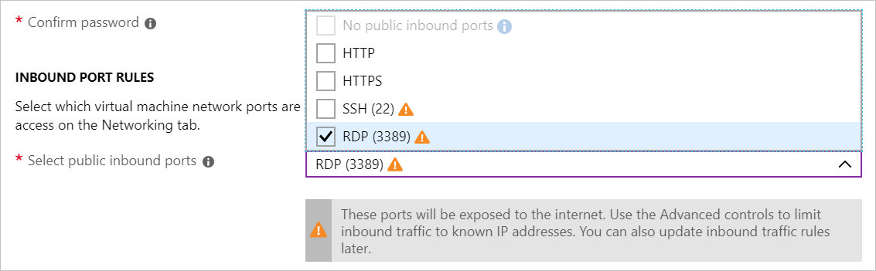

**Configure Disks for the VM**

1. Click **Next** to move to the Disks section.

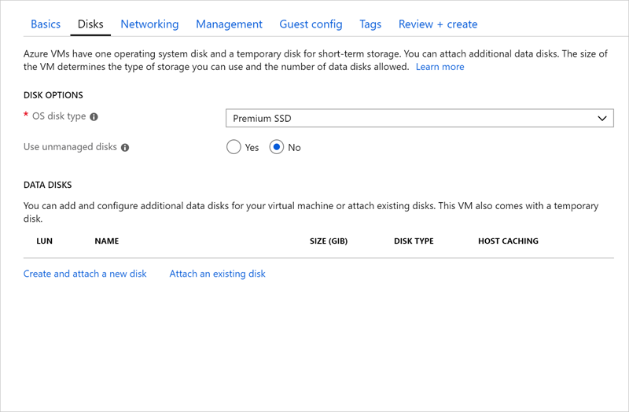

1. Choose "Premium SSD" for the **OS disk type**.
2. Use managed disks so we don't have to work with storage accounts. You can flip the switch in the GUI to see the difference in information that Azure needs if you like.

**Create a data disk**

Recall we will get an OS disk (C:) and Temporary disk (D:). Let's add a data disk as well.

1. Click the **Create and attach a new disk** link in the **DATA DISKS** section.

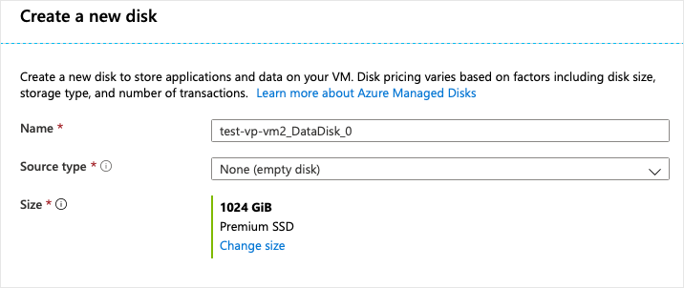

1. You can take all the defaults: Premium SSD, 1023 GB, and None (empty disk); although notice that here is where we could use a snapshot, or Storage Blob to create a VHD.
2. Click **OK** to create the disk and go back to the **DATA DISKS** section.
3. There should now be a new disk in the first row.

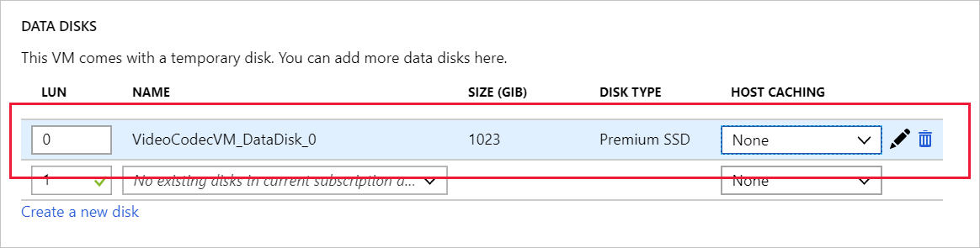

**Configure the Network**

1. Click **Next** to move to the Networking section.
2. In a production system, where we already have other components, we'd want to utilize an *existing* virtual network. That way our VM can communicate with the other cloud services in our solution. If there isn't one defined in this location yet, we can create it here and configure the:
   * **Address space**: the overall IPV4 space available to this network.
   * **Subnet range**: the first subnet to subdivide the address space - it must fit within the defined address space. Once the VNet is created you can add additional subnets.
3. Let's change the default ranges to use the 172.xxx IP address space. Click **Create New** under Virtual Network.
   * Change the **Address space** field to be 172.16.0.0/16 to give it the full range of addresses
   * Change the **Subnet range** field to be 172.16.1.0/24 to give it 256 IP addresses of the space.
4. Click **OK**.

**Note**

By default, Azure will create a virtual network, network interface, and public IP for your VM. It's not trivial to change the networking options after the VM has been created so always double-check the network assignments on services you create in Azure.

**Finish configuring the VM and create the image**

The rest of the options have reasonable defaults and there's no need to change any of them. You can explore the other tabs if you like. The individual options have an (i) icon next to them that will show a help bubble to explain the option. This is a great way to learn about the various options you can use to configure the VM.

1. Click the **Review + create** button at the bottom of the panel.
2. The system will validate your options and give you details about the VM being created.
3. Click **Create** to create and deploy the VM. The Azure dashboard will show the VM that's being deployed. This may take several minutes.

While that's deploying, let's look at what we can do with this VM.

**Connect to the VM with Remote Desktop Protocol**

To connect to an Azure VM with an RDP client, you will need:

* The public IP address of the VM (or private if the VM is configured to connect to your network).
* The port number.

You can enter this information into the RDP client, or download a pre-configured **RDP** file.

**Note**

An **RDP** file is a text file that contains a set of name/value pairs that define the connection parameters for an RDP client to connect to a remote computer using the Remote Desktop Protocol.

**Download the RDP file**

1. In the [Azure portal](https://portal.azure.com/learn.docs.microsoft.com), ensure the **Overview** panel for the virtual machine that you created earlier is open. You can find the VM under **All Resources** if you need to open it. The overview panel has a lot of information about the VM.
   * You can see whether the VM is running.
   * Stop or restart it.
   * Get the public IP address to connect to the VM.
   * See the activity of the CPU, disk, and network.
2. Click the **Connect** button at the top of the pane.
3. In the **Connect to virtual machine** pane, note the **IP address** and **Port number** settings, then click **Download RDP File** and save it to your computer.
4. Before we connect, let's adjust a few settings. On Windows, find the file using Explorer, right-click and select **Edit**. On MacOS you will need to open the file first with the RDP client and then right-click on the item in the displayed list and select **Edit**.
5. You can adjust a variety of settings to control the experience in connecting to the Azure VM. The settings you will want to examine are:
   * **Display**: By default, it will be full screen. You can change this to a lower resolution, or use all your monitors if you have more than one.
   * **Local Resources**: You can share local drives with the VM - allowing you to copy files from your PC to the VM. Click the **More** button under **Local devices and resources** to select what is shared.
   * **Experience**: Adjust the visual experience based on your network quality.
6. Share your Local C: drive so it will be visible to the VM.
7. Switch back to the **General** tab and click **Save** to save the changes. You can always come back and edit this file later to try other settings.

**Connect to the Windows VM**

1. Click the **Connect** button to start the connection to the VM.
2. In the **Remote Desktop Connection** dialog box, note the security warning and the remote computer IP address, then click **Connect**.
3. In the **Windows Security** dialog box, enter your username and password that you used in steps 6 and 7.

**Note**

If you are using a Windows client to connect to the VM, it will default to known identities on your machine. You can click the **More choices** option and select "Use a different account" to let you enter a different username/password combination.

1. In the second **Remote Desktop Connection** dialog box, note the certificate errors, then click **Yes**.

**Install worker roles**

The first time you connect to a Windows server VM, it will launch Server Manager. This allows you to assign a worker role for common web or data tasks. You can also launch the Server Manager through the Start Menu.

This is where we would add the Web Server role to the server. This will install IIS and as part of the configuration you would turn off HTTP requests and enable the FTP server. Or, we could ignore IIS and install a third-party FTP server. We'd then configure the FTP server to allow access to a folder on our big data drive we added to the VM.

Since we aren't going to actually configure that here, just close Server Manager.

**Install custom software**

We have two approaches we can use to install software. First, this VM is connected to the Internet. If the software you need has a downloadable installer, you can open a web browser in the RDP session, download the software, and install it. Second, if your software is custom - like our custom service, you can copy it from your local machine over to the VM to install it. Let's look at this latter approach.

1. Open File Explorer. Click on **This PC** in the sidebar. You should see several drives:
   * Windows (C:) drive representing the OS.
   * Temporary Storage (D:) drive.
   * Your local C: drive (it will have a different name than shown below).

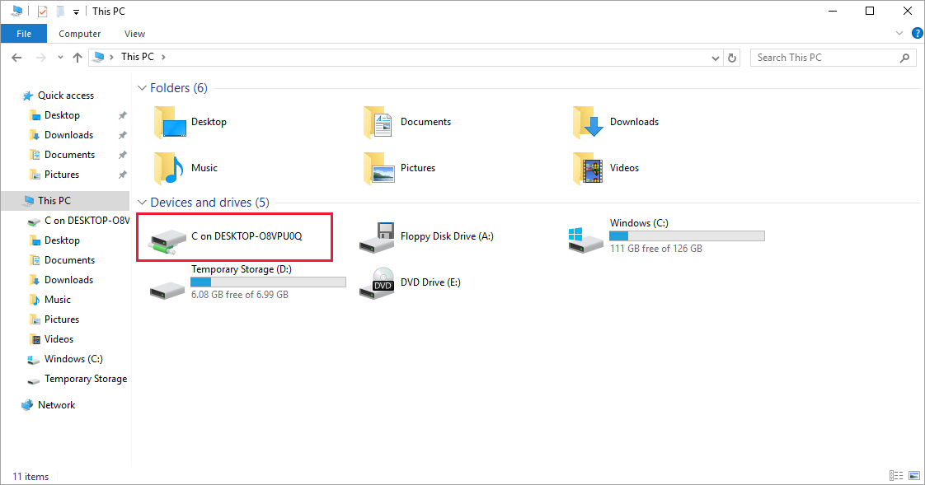

With access to your local drive, you can copy the files for the custom software onto the VM and install the software. We won't actually do that since it's just a simulated scenario, but you can imagine how it would work.

The more interesting thing to observe in the list of drives is what is *missing*. Notice that our **Data** drive is not present. Azure added a VHD but didn't initialize it.

**Initialize data disks**

Any additional drives you create from scratch will need to be initialized and formatted. The process for doing this is identical to a physical drive.

1. Launch the **Disk Management** tool from the Start Menu. You may have to go to the Computer Management tool first, then Disk Management, or try searching for "Disk Management" in the Start Menu.
2. It will display a warning that it has detected an uninitialized disk.

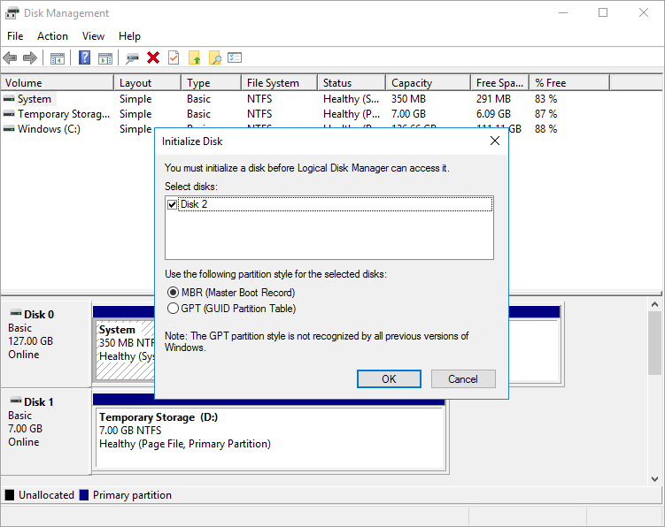

1. Click **OK** to initialize the disk. It will then show up in the list of volumes where you can format it and assign a drive letter.
2. Open File Explorer and you should now see your data drive.
3. Go ahead and close the RDP client to sign out of the VM. The server will continue to run.

RDP allows you to work with the Azure VM just like a local computer. With Desktop UI access, you can administer this VM as you would any Windows computer: installing software, configuring roles, adjusting features and other common tasks. However, it's a manual process - if we always need to install some software, you might consider automating the process using scripting.